Thursday, August 24, 2023 – 10 a.m.

Contact: 509-557-0973 or the Wenatchee River Ranger District office, 509-548-2550

**Airplane Lake Fire Update**

* Size: 2,298 acres
* Containment: 0%
* Location: On the northeast side of Mt. Saul in the White River drainage area of the Glacier Peak Wilderness Area.
* Personnel assigned: monitoring personnel and helicopter personnel as needed.
* Start date: July 7, 2023
* Cause: Lightning
* Closures: Areas immediately around the fire are closed including White River Trail, Boulder Creek Trail, Indian Creek Trail, White River Road beyond Tall Timbers, White River Falls Campground, and Grasshopper Meadows Campground. Go to this link <https://www.fs.usda.gov/alerts/okawen/alerts-notices/?aid=82646> to read the closure order.
* Evacuations: Chelan County has issued a Level 1 (Ready) evacuation notice for the White River Road (FS Road 6400) to the west of Tall Timbers Ranch. The Level 1 DOES NOT impact any county roads or right-of-way, or homes. It also does not impact Tall Timber Lodge. ([https://www.facebook.com/CCSOEM/posts/pfbid02CTRFQrkYkmvaRdvuu57CJKhTgMLW7HWvv84nFhevqKXqWau3BntPbVJnFAvYd5psl](https://www.facebook.com/CCSOEM/posts/pfbid08un4Vh8Bufq1umzADzTGSyoDK66ieG5RqUFG85LAaYCvDn29w6Vw5FNy3N9yyCkxl?__cft__%5b0%5d=AZV826mc7HQtG8MhQ6UXtlRVV0tgGNVozzc4GjBFHsmsjsay5E27ZGDZnPpsAOlAVqRLVuxoWBxAEMhAF8zrwqgZ9vUJTrvqjjw6OsdMEaldTd8P7sg_9yHrMCaFCVkiJt1d9K5VyczporBMNS3P6YGMn2rhY_yyyk-XLS6bEhTKrBTNWR8Pg7vUt86s0W7ccvI&__tn__=-UK-R))

The fire is burning in the Glacier Peak Wilderness Area. Most of the fire’s growth over the last couple of days has occurred on the west side of the fire. The fire’s progression to the south has been limited due to the use of a large helicopter doing water drops in strategic locations to halt the spread. Fire personnel will continue to assess the situation and take advantage of opportunities to control the fire utilizing natural features (like rock escarpments, wet drainage bottoms and old fire scars) to contain the fire. Fire personnel will continue to monitor and evaluate the situation and adjust tactics as needed.

Cooler temperatures over the past couple of days have helped decrease fire behavior along the fire’s perimeter. Even though fire behavior has decreased, the fire is still actively backing in Amber Creek and the White River drainages.

The weather forecast is for a temporary warming trend to occur on Thursday, Friday, and Saturday followed by a storm system that may bring in some moisture. Saturday and Sunday temperatures are predicted to be in the 70’s near the fire’s location. A low-pressure system working its way in off the coast of Washington could also present the possibility of east winds through the weekend.

Forest Service road crews will be doing roadside maintenance work to address access issues along FS Road 6400, north of Tall Timber Ranch.

An area closure is in effect for public safety. Level One Evacuation remains in place (issued by Chelan County for the White Rive Road FS6400 to west of Tall Timbers). Visit Chelan County Emergency Management for more information regarding evacuation notices.

Information will be updated at least twice a week or after any significant event occurs. For more information contact the Wenatchee River Ranger District office at 509-548-2550.

We ask people to help do their part to reduce the risk of human-caused fires and follow campfire restrictions:  <https://www.fs.usda.gov/detail/okawen/alerts-notices/?cid=fsbdev3_053600>

-End-

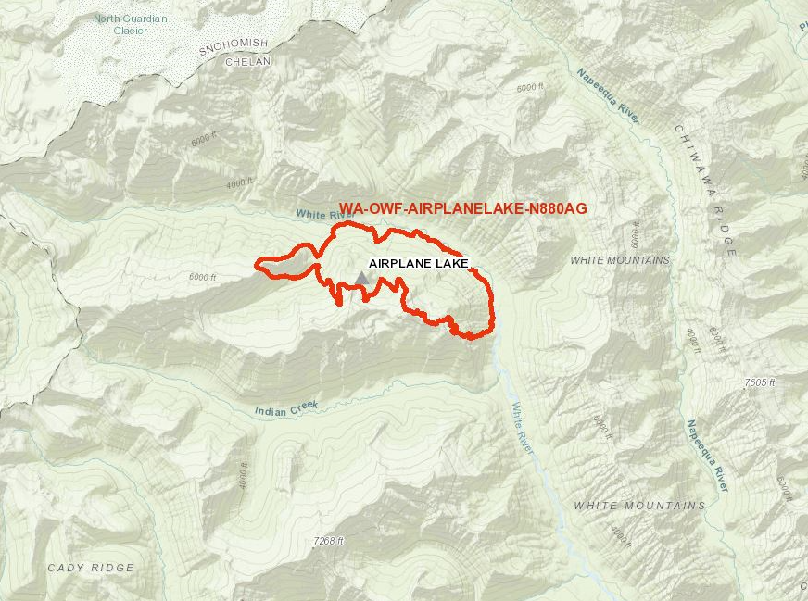

Airplane Lake Fire map as of August 23, 2023. The fire is estimated to be 2,298 acres in size.

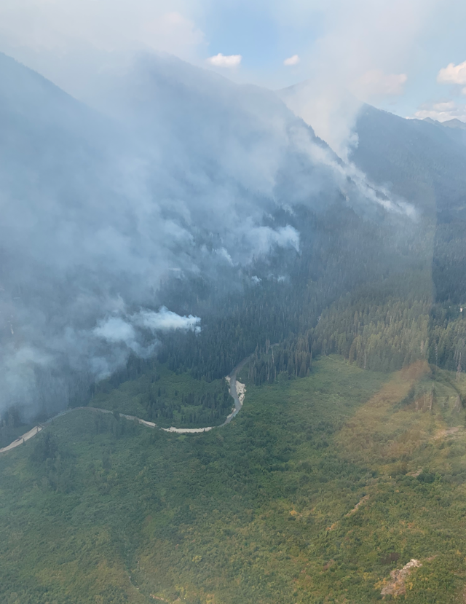 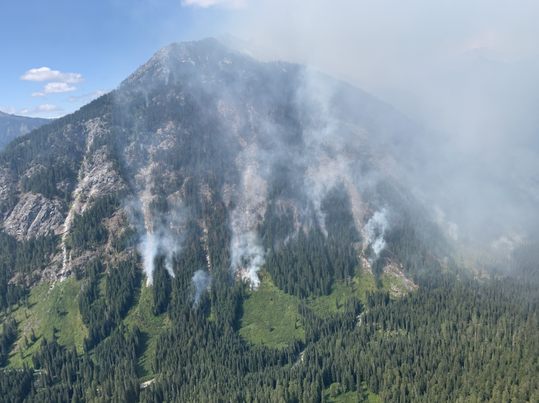

Phots of the Airplane Lake Fire taken on August 22, 2023.

Credit: U.S. Forest Service by Benton Merritt

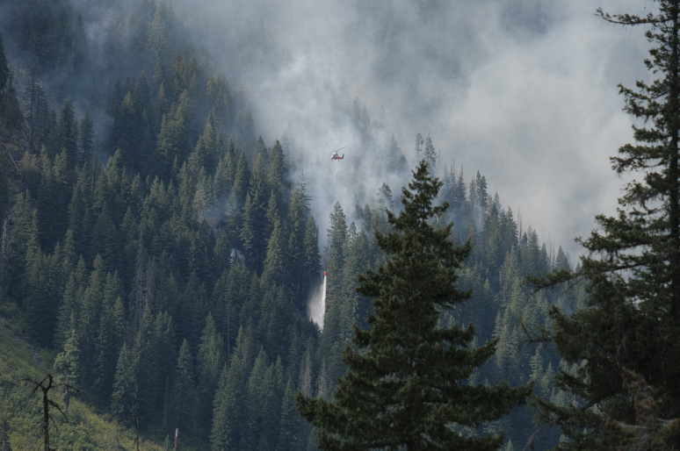

Helicopter water drops aided in limiting the fire’s spread to the south.

Credit: U.S. Forest Service by Dan Hilden

View of the Airplane Lake Fire from a remote camera.